

Product Catalog System

How to login
First head to https://catalogue.pain.com.my/auth/login
Then press sign in
Then enter your email and password to login

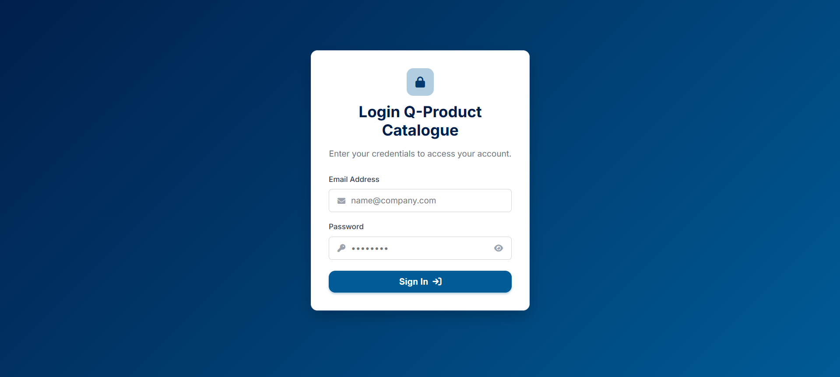
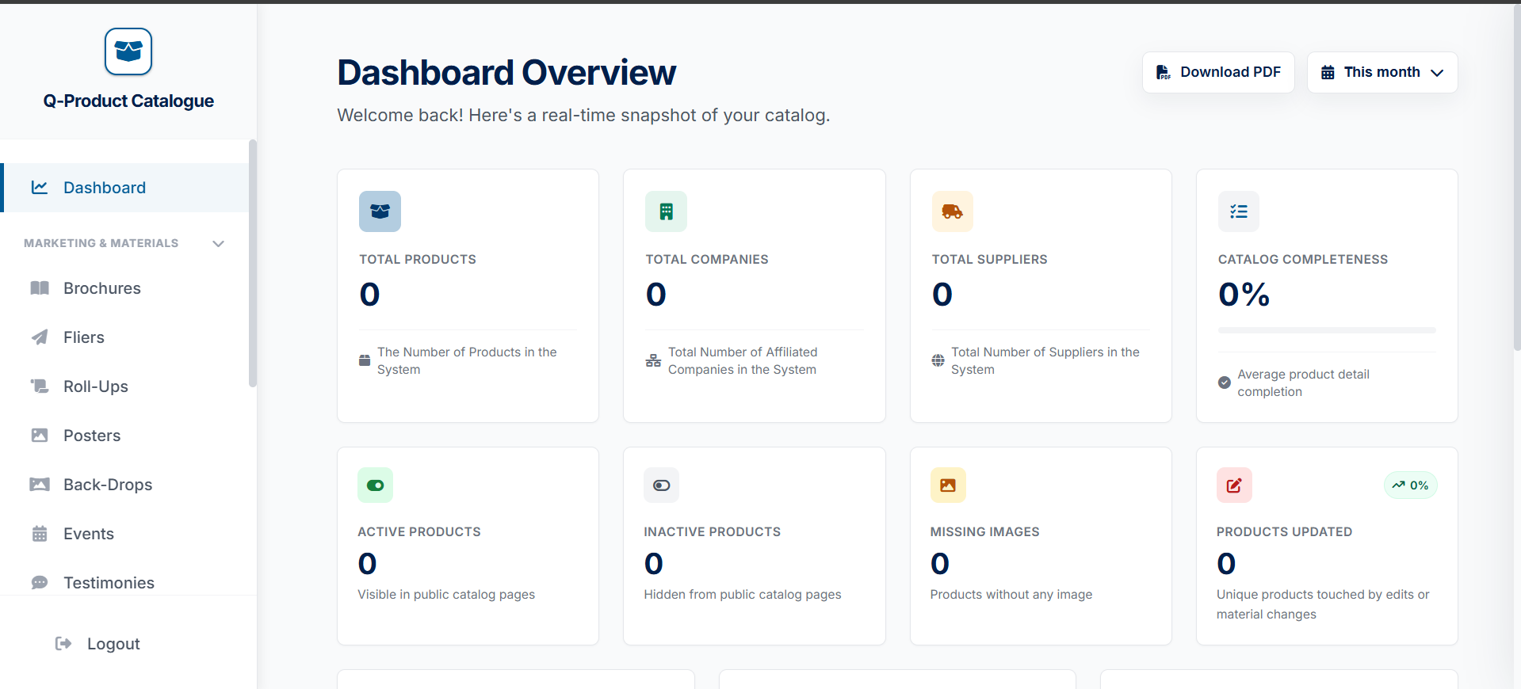
You would be brought to the dashboard after signing in by default

